/\*july26\*/

select \* from emp where salary=(select max(salary) from emp);

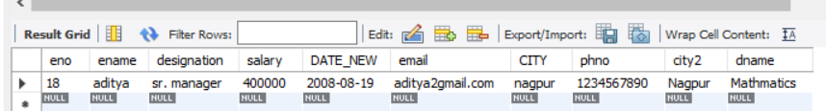

select \* from emp where salary=(select min(salary) from emp where city in('pune','mumbai') and ename like '%a%' or ename like '%i%' );

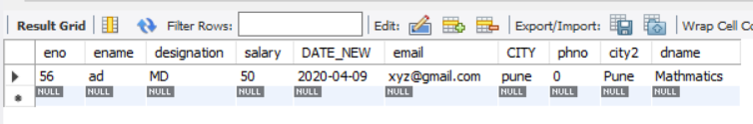

alter table emp add column dnmae varchar(30);

alter table emp change dnmae dname varchar(50);

update emp set dname='computer science' where eno<=5;

update emp set dname='Electronics' where eno between 5 and 10;

update emp set dname='Mathmatics' where eno>=10;

/\*select dname from emp group by dname;\*/

select ename,dname from emp group by ename,dname;

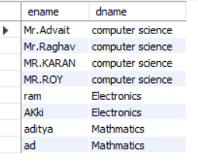

select sum(salary),dname as total from emp group by dname;

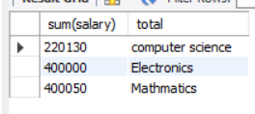

select avg(salary),dname from emp group by dname

having dname='computer science';

